Practical-7 Bluetooth
🔹 Execution Steps
- Open Arduino IDE on your computer.
- Connect your Arduino UNO via USB.
- Paste this code into a new sketch:
#include <SoftwareSerial.h>
SoftwareSerial BTSerial(2, 3); // RX, TX

void setup() {
Serial.begin(9600);
BTSerial.begin(9600);
Serial.println("Bluetooth ready");
}
void loop() {
if (BTSerial.available())
Serial.write(BTSerial.read());
if (Serial.available())
BTSerial.write(Serial.read());
}

NOTE: CODE IS PRESENT IN THE ARDUINO IDE ALREADY
GO TO File → Open → choose “Exp_7”

- Upload the code to your UNO (Ctrl + U).
- Open Serial Monitor (Ctrl + Shift + M):
  - Baud rate: 9600
  - Line ending: No line ending
- Power your HC-05 (it should already be wired to the UNO).
  - LED should blink fast (2 blinks per second) = normal mode.
- On your Android phone:
  - Open Serial Bluetooth Terminal app.
  - Go to Settings → Devices → “HC-05” → tap Connect.
  - The LED on the module will change to slow double blink or steady on (connected).
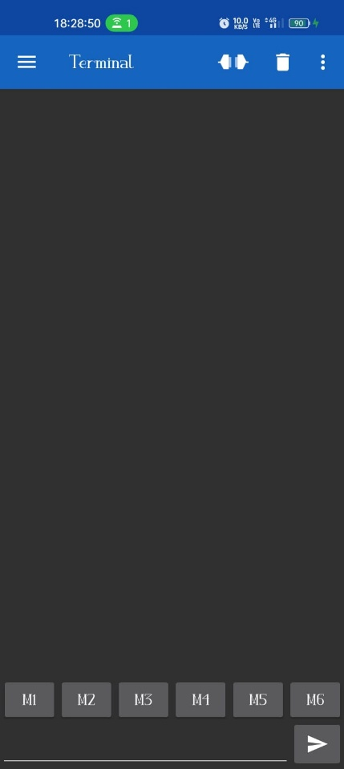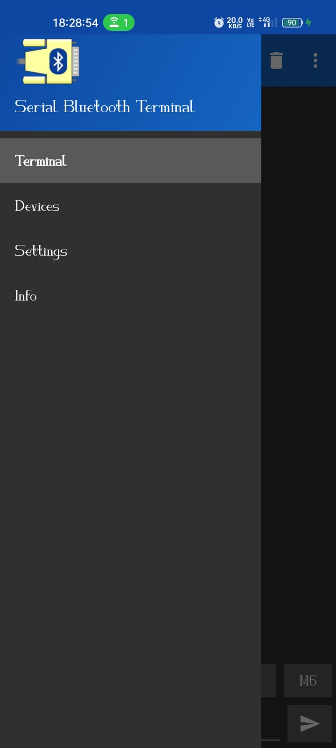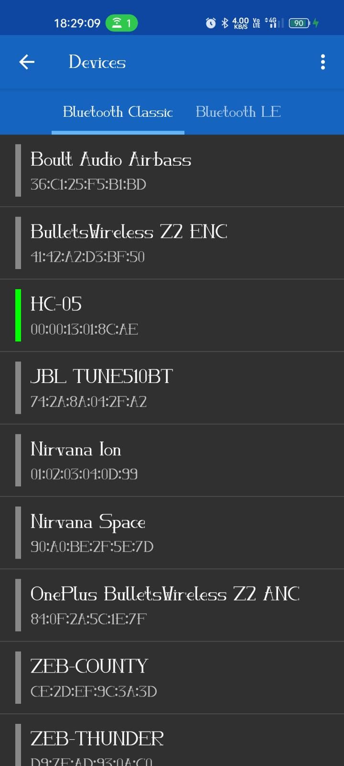
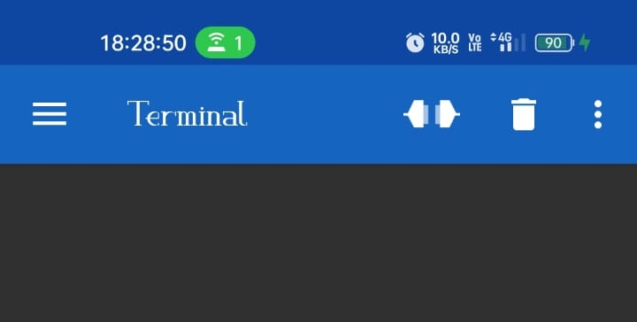
- Test communication:
  - In the phone app, type a message → press send → you’ll see it appear in Arduino Serial Monitor.
  - In Arduino Serial Monitor, type a message → press send → it appears instantly in the phone app.

OUTPUT:
HARDWARE
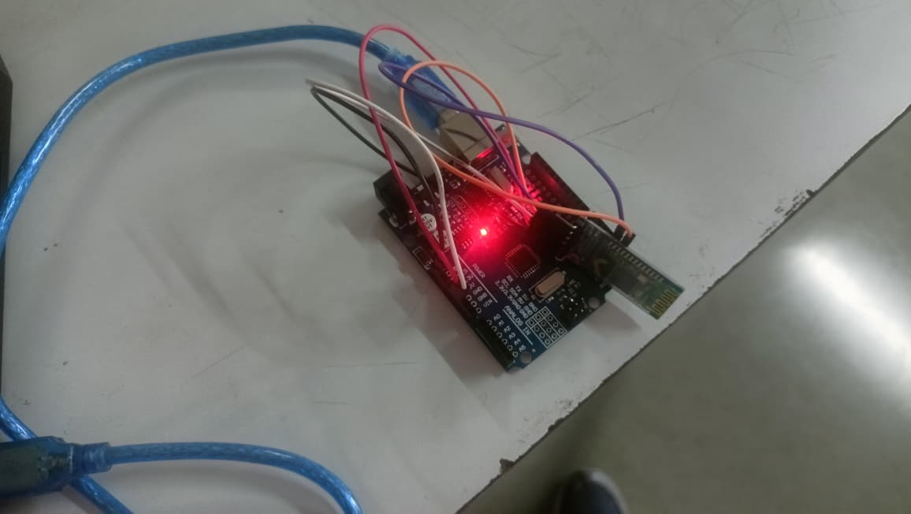

SERIAL TERMINAL
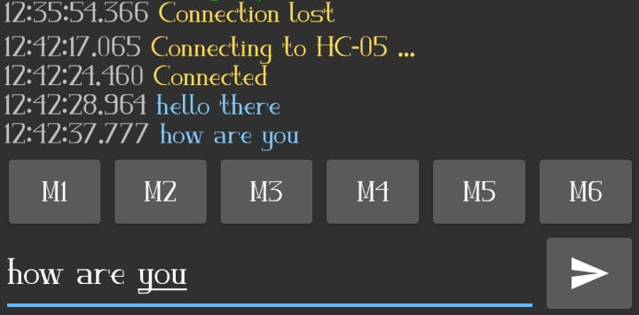
SERIAL MONITOR

